# Software Engineering Assignment 1

* The project we undertook was to make a calculator with particular specifications.
* We followed the prototype model for this project to get continuous customer input and maintain customer satisfaction.

### Requirement Collection-

* The customer wanted a functional calculator with a good user interface.
* It was required to have a unique feature which other calculators would not have.
* We included a random quote generator as well as a textual display (in words) of the result in our design.
* The calculator design also included a display of the date and time.
* The calculator was expected to look good and also be easy to use.

### Feasibility Study-

* We decided it would very accessible if the calculator was made on a webpage. Anyone could access it if they had the link.
* We decided to host it on github so that version control would be easy. It is easy to modify and keep track of changes this way.

### Prototype Development-

* Based on the requirements, a prototype was made in html.

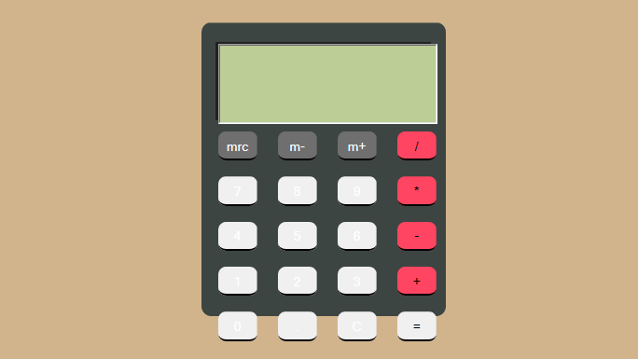

* As you can see, the model was very basic and the user interface lacked beauty.
* The buttons were barely visible and the buttons exceeded the frame of the calculator.

### Prototype Testing-

* Upon checking the functionalities, it was found that the calculator gave errors for negative integers.

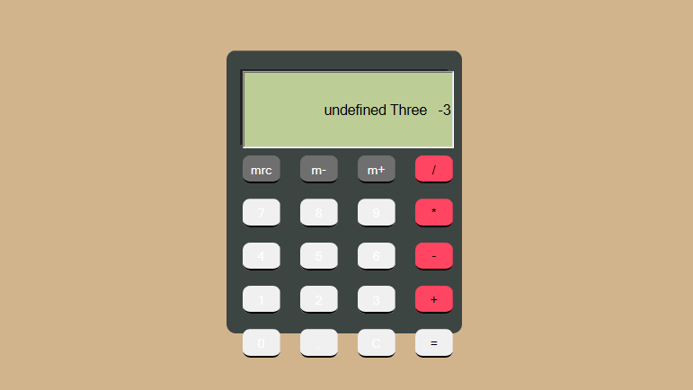

* There was also an error with displaying the error message when divided by zero.

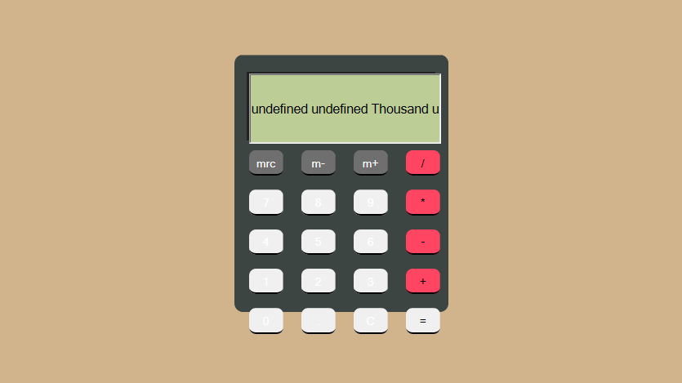

### Customer Review-

* The customer had a few suggestions and changes to be made after seeing the prototype.
* We were required to increase the aesthetic beauty of the calculator.
* Also, the customer did not like the static background. It made the product look dull.
* The calculator also didn’t include the extra features such as quotes and date and time display.
* Taking into account all the functionality problems and customer’s modifications, CSS and JavaScript functionality was improved.

### Design-

* A new design was created which included options to view the quotes and date and time. The interface was also changed to make it user friendly and beautiful.

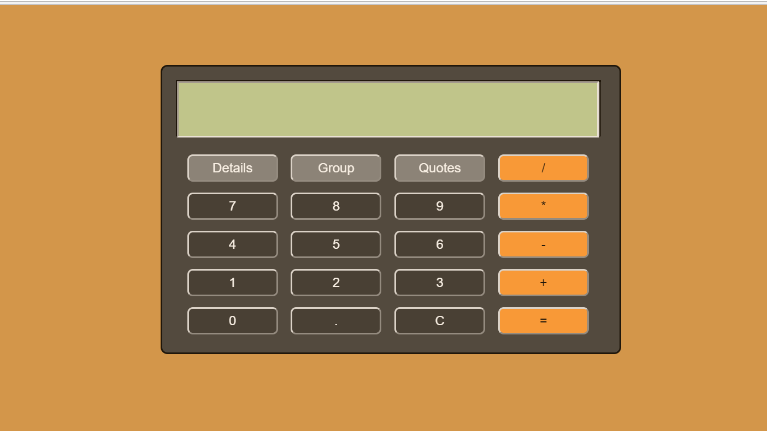

* A random background colour generator feature was added.
* The negative number problem was also solved as seen below.

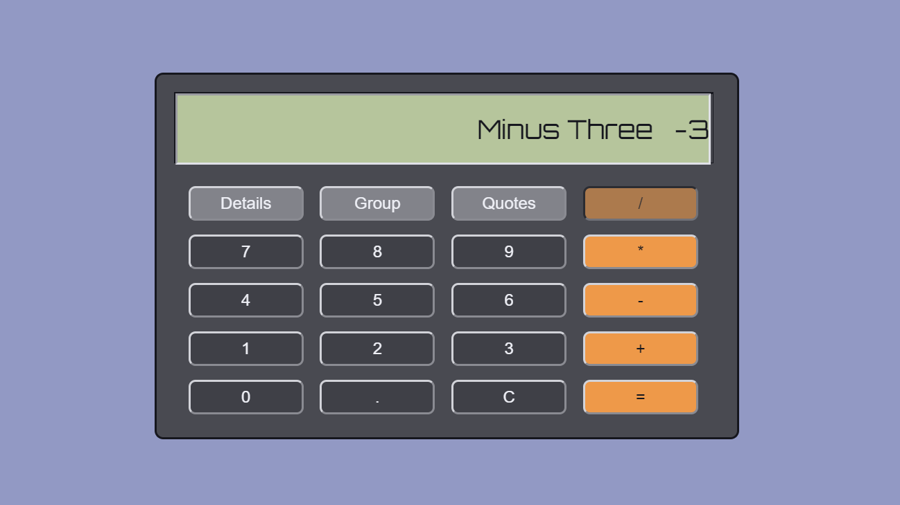

* The quotes feature and date and time feature was also added.

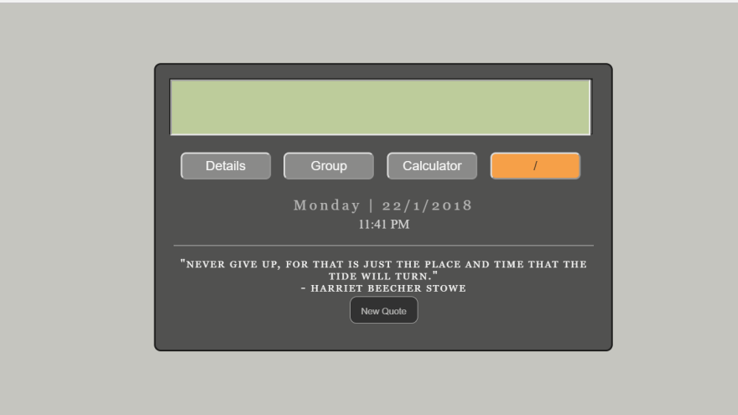

### Testing and Customer Approval-

* The final design passed all tests and functioned perfectly. The negative number problem was solved and any error message was displayed perfectly.
* It was shown to the customer and they had approved of the product.
* We then moved on to final touches and launched the calculator.

### Installation and Maintenance-

* We launched the calculator and hosted it on github for free. It is accessible by anyone who has the website link to the calculator.
* Maintenance is close to zero because there are no changes or updates required at time intervals.

### THE FINAL PRODUCT-

<https://batmosphere.github.io/Calculator/Calculator.html>